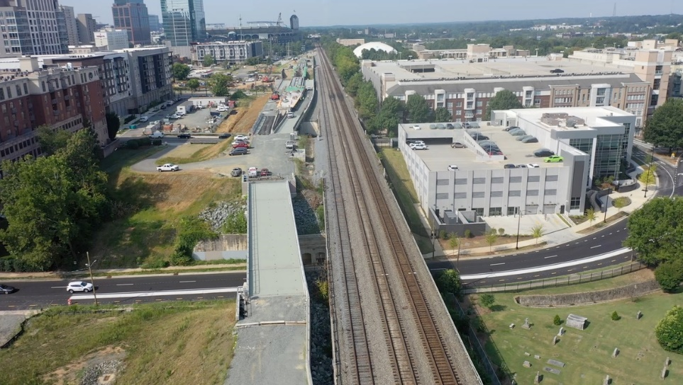

=
Photo credit Volkert
Charlotte Gateway Station Expansion

Challenge:
Project Details
Client: Blythe Construction
Location: Charlotte, NC
GRL Office: North Carolina
Non-destructive integrity testing was required for the expansion of an existing rail line in Charlotte, North Carolina. The contracted firm, Blythe Construction, secured the services of GRL Engineers to perform integrity testing on the drilled shafts for the station construction. The project specified both crosshole sonic logging and thermal integrity profiling to be performed. GRL Engineers used this project as an opportunity to observe and compare the quality and cost of the two data collection methods.
Method:
GRL Services
- Thermal Integrity Profiling
- Crosshole Sonic Logging
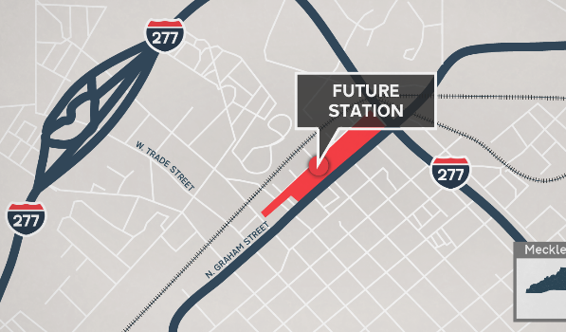
The Gateway Station Phase 1 foundation required CSL and TIP testing to be performed on each of the 7 foundation shafts. The drilled shafts had an average length of 66.3 ft and a nominal diameter of 5 feet. The CSL tests required a total of 2,730 linear ft of tubing while the TIP testing required 2,500 linear ft of Thermal Wire cable. CSL equipment costs accounted for linear feet of tubing, caps, labor to install the tubes, and post grouting per linear ft. TIP testing costs considered the Thermal Wire cable length, connectors, and labor to install the wires.

To perform the CSL test, the tubes must be filled with water and the GRL Engineer must lower the CSL probes to the bottoms of the tubes. Once the probes have reached the bottom, testing can begin as the probes are raised in unison. The testing equipment generates electrical signals which are converted to ultrasonic vibrations which travel through the concrete from the transmitter to the receiver, which converts the vibrations back to an electrical signal, which is recorded by the CHA system. Both the time between pulse generation and signal reception (FAT for first arrival time) and the strength of the received signal are displayed on the engineer’s tablet for review. The concrete must be adequately cured before a CSL test can be performed, which typically takes 7 days after concrete placement.
Photo credit NC DOT

To perform the TIP test, the GRL engineer provided instruction to Blythe on how to install the Thermal Wire cables along the length of the reinforcing cage. After concrete placement, the cables were attached to data collection boxes (TAG & TAP Edge) which collect temperature data during the curing process. The data collection boxes push data to a secure cloud storage system, through the cellular phone network. The TIP data loggers collect data continuously from the end of concrete placement until the peak temperature is achieved, which occurred approximately 24 hours after concrete placement.

Results:
When comparing the costs, the material costs for the TIP testing were 43% less than the material costs for the CSL Testing. It is evident that the TIP test method provides potential cost savings; additionally, there is a clear potential to accelerate project timelines with TIP testing, since only 24 hours was needed after concrete placement to obtain the data, as opposed to 7 days with CSL testing. In terms of data quality, both methods have limitations. In this project, the initial CSL results indicated that 4 of the 7 drilled shafts could have potential anomalies. From the initial TIP results, 2 of the 7 drilled shafts were reported to have anomalies. With the addition of the TIP testing on this project, it was determined that additional CSL testing was required on three of the shafts, which confirmed the TIP results to be correct. Of the four shafts with suspected anomalies, only one shaft required additional investigation. Without TIP testing, the remaining shafts with suspected anomalies may have required additional testing.

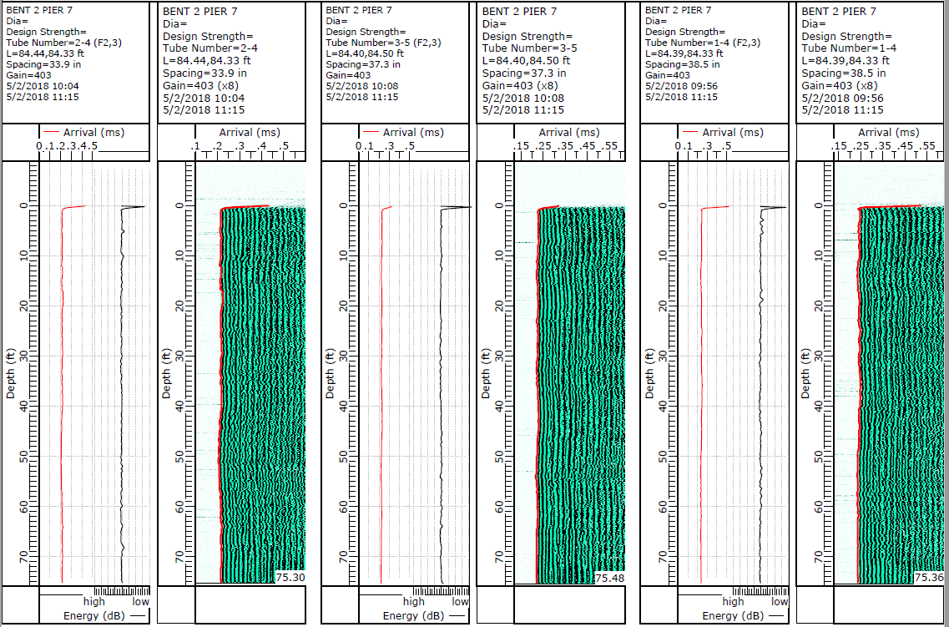
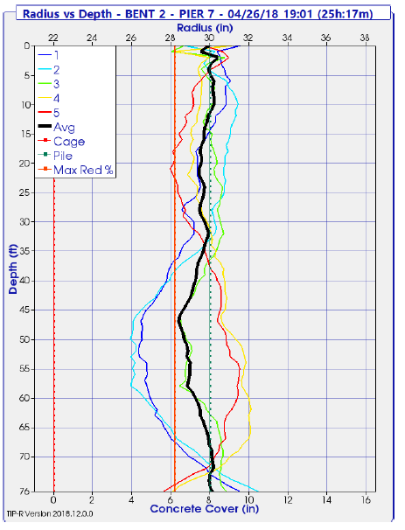
Figure 1: TIP Results Displaying Radius vs Depth
Figure 2: Representative Sample of CSL Results

To learn more about non-destructive integrity testing, read reference paper: COST AND TECHNICAL COMPARISON OF NON-DESTRUCTIVE TEST METHODS FOR DRILLED SHAFTS, or visit www.grlengineers.com.

