**SAMPLE SPECIFICATION for HIGH STRAIN DYNAMIC TESTING of DRIVEN PILES**

May 15, 2024

*In using this sample specification, it should be recognized that each site and structure is unique. Therefore, geotechnical judgment based upon knowledge of the local soil conditions and deep foundation installation practice should be used to modify this sample specification to address the requirements of a specific project.*

**1.0 - GENERAL**

**1.1 Summary of Work.** Dynamic testing involves attaching at least two strain transducers and two accelerometers to the pile near the pile head during initial driving or at a convenient location during re-strike testing. A cable or wireless transmitter connects the sensors near the pile head with the Pile Driving Analyzer® (PDA) system (available from Pile Dynamics, Inc., 30725 Aurora Road, Cleveland, OH 44139, USA; [www.pile.com/pdi](http://www.pile.com/pdi); email: info@pile.com; phone: +1 216-831-6131; or equivalent, located a safe distance from the pile, but not more than 330 ft from the pile.

***Commentary:*** *In most instances, dynamically tested piles should be specified to be a few ft longer than standard pile lengths so that sensors are not driven into the ground. This and subsequent commentary – in parenthesis - are provided only for guidance and can be deleted, making the actual specifications relatively brief.*

**1.1.1 Indicator Piles**. The (Owner, Engineer, Contractor, Quality Control Agency) shall secure the services of a Dynamic Testing Consultant. Dynamic testing shall be performed on ____ indicator piles during the final ____ ft of initial driving and/or during restrike a minimum of ____ days after initial driving. The number of indicator piles is based upon structure type and size as well as subsurface variability. For example, one indicator pile for every 5,000 ft² of building footprint or two per bridge pier may be appropriate depending upon subsurface conditions. A typical test during installation is during last 10-40 ft for steel or timber piles, or full length for concrete piles due to concerns about early driving tension stresses. Restrike interval is based upon the time required for time dependent soil strength changes to take place. Typical values may be 1-2 days for piles driven into clean sands or to hard rock and 5-10 days for piles driven into silts, silty sands, clays or to soft rock such as shale.

**1.1.2 Production Piles**. Dynamic pile testing shall also be performed on ____ production piles as chosen by the Engineer. The production pile testing shall be performed during ____ (initial driving, restrike, initial driving and restrike) to monitor hammer and drive system performance (additional tests required following any hammer or driving system modifications or if another hammer is to be used on the site), assess pile installation stresses and integrity, as well as to evaluate pile capacity. Typically testing includes 5%-10% of the production piles, or a select number of piles per week, every other week, or month depending upon project size and subsurface variability. On small projects, production pile testing may be unnecessary. Including a contingency testing provision is suggested in case of unexpected problems or unusual production piling records. On large projects and projects with multiple driving systems, production pile testing is an important quality control tool. If the dynamic testing is primarily to monitor drive system performance and driving stresses, then testing should be performed during initial driving. If pile capacity evaluation is the primary purpose, production pile testing should also include restrike after time dependent soil strength changes and generally results in increased capacity from “set-up” and therefore reduced foundation costs. If all dynamic testing information is desired, testing should be specified during both initial and restrike driving. It should be noted that restrike testing of production piles more than one day after installation may significantly alter the contractor's sequencing, depending on site conditions. Therefore, if restrike testing for pile capacity evaluation is important, it should clearly be identified on plans and specifications as well as the method of compensation for out of sequence moves, if applicable.

**1.2 Equipment and Personnel.** The dynamic monitoring shall be performed using a Pile Driving Analyzer® system (Model 8G or PAX). All equipment necessary for dynamic monitoring such as sensors, cables or wireless transmitters, etc., shall be furnished by the Dynamic Testing Consultant. The equipment shall conform to the requirements of ASTM D-4945. An engineer with a minimum __ years of experience __ (and/or) who has achieved ____ (Basic, Intermediate, Advanced, Master) Level or better on the PDI / PDCA Dynamic Measurement and Analysis Proficiency Test shall oversee PDA operation and of result interpretation, either on site or by remote connection (SiteLink®). Recommendations about the Proficiency Test can be viewed on [www.PDAProficiencyTest.com](http://www.PDAProficiencyTest.com). This will indicate if the testing personnel have sufficient knowledge to properly perform the test and interpret the results.

**2.0 - PRECONSTRUCTION**

**2.1 Preconstruction Wave Equation Analysis.** _____ (Five, Ten, etc) working days prior to driving the indicator piles, the Contractor shall submit the “Pile and Complete Driving Equipment Data Form (see Appendix) to the (Engineer, Dynamic Testing Consultant). The (Engineer, Dynamic Testing Consultant) shall use the submitted information to perform wave equation analyses and shall prepare a summary report of the wave equation results. The wave equation analysis (using GRLWEAP software by Pile Dynamics, Inc. or equivalent) shall be used to assess the ability of the proposed driving system to install the pile to the required capacity and desired penetration depth within the allowable driving stresses. See Appendix for typical recommended driving stress limits. If the wave equation analysis results in stresses approaching these limits, consideration to revise the driving should be considered. Approval of the proposed driving system by the Engineer shall be based upon the wave equation analyses indicating that the proposed driving system can develop a pile capacity of ____ kN (kips) (pile design load times 2.5) at a driving resistance not greater than ____ in/blow within allowable driving stress limits. The hammer should also be sized or adjustable such that the penetration per blow at the required ultimate capacity does not exceed 0.5 in.

***Commentary****: The purpose of this section is to specify a hammer capable of installing the piles to the desired depth and capacity in the event of unexpected soil behavior or poor drive system performance. A typical driving resistance of 5-9 blows/in might be specified for friction piles or 10 blows/in for end bearing piles or values typical for local practice. The hammer size or blow count requirements are not needed when driving a pile to a depth rather than a blow count criterion. Driving to a minimum elevation should only be specified when geotechnical conditions warrant such a requirement (e.g. scour, lateral fixity, settlement from compressible layers, uplift).*

A new pile driving system, modifications to existing system, or new pile installation procedures shall be proposed by the Contractor if the pile installation stresses calculated by wave equation analysis or derived from the Pile Driving Analyzer measurements exceed the maximum values specified by the Engineer or shown in the Appendix. Thus compression stresses should be less than _____ MPa (ksi) and tension stresses should be less than _____ MPa (ksi).

***Commentary****: The Engineer's recommended maximum allowable driving stresses should be specified for the pile type and installation conditions. Recommended values are attached in Table 1 for informational purposes.*

1. **– DYNAMIC TEST EXECUTION**

**3.1 Construction Access.** To prepare the pile for sensor attachment, a drill of sufficient power, operated by a DC battery, shall be available. A hammer drill is required for preparation of concrete piles. Prior to lifting the pile to be dynamically tested, the Contractor shall provide a minimum of 3 ft of clear access to 180-degree opposite faces of the pile for pile preparation. The Dynamic Testing Consultant or the Contractor's personnel shall then drill and prepare holes for sensor attachment. Sensors are usually attached near the pile top.The Contractor's personnel shall attach the sensors to the pile after the pile has been driven to the penetration depths identified in Part 1.1. If wireless transmitters are used, sensors may be attached to the pile prior to lifting the pile into the leads; the wireless transmitters and sensors shall be covered with protection devices, if appropriate. Driving shall then continue using routine pile installation procedures. When the level of the sensors is within 1 ft of any obstruction endangering the survival of sensors or cables, driving shall be halted to remove the sensors from the pile. If additional driving is required, the obstruction shall be removed or the pile shall be spliced and the sensors shall be reattached to the head of the next pile segment prior to the resumption of driving.

**3.2 Testing Procedures.**

**3.2.1 Indicator Piles.** Indicator piles shall be driven to an ultimate capacity of ____ kN (kips) based upon the preliminary driving resistance indicated by wave equation results. Adjustments to the preliminary driving criteria may be made by the Engineer based upon the dynamic testing results.

***Commentary****: This ultimate capacity is often specified as 2.0 times the design load if Allowable Stress Design approach is used and static testing or substantial dynamic testing are specified in the indicator pile program, or 2.25 times the design load if only minimal dynamic testing is planned (For Load Resistance Factor Design based codes, the type and extensiveness of testing will likewise influence resistance factors). The Engineer may also select other safety or resistance factors depending upon structural considerations, subsurface variability, and the design codes being followed. For LRFD applications for bridges in USA, the “ultimate capacity” is usually called “nominal resistance” and is shown on the plans. Alternatively, in localities or soils (such as clay) where significant soil setup effects are known to exist, specifications may require a minimum pile penetration depth or to drive indicator piles to pre-selected variable depths regardless of driving resistance or end of driving capacity. Restrike dynamic testing is then essential to evaluate pile capacities after soil setup.)*

Based upon the dynamic testing results, driving records and subsurface conditions, the Engineer shall (may) select ____ (number) indicator piles to be statically load tested in accordance with specification section ___.

***Commentary****: This section references a static load testing section, if any. If static testing provisions are not considered, then this section can be deleted.*

All indicator piles shall be re-driven with dynamic testing after a minimum waiting period of ____ days (____hours) unless a pile has been selected for static load testing. The pile(s) which is(are) statically load tested shall be re-struck with dynamic testing within 48 hours after completion of the static load test to obtain a correlation between static and dynamic test results for reference across the site. The restrike driving sequence shall be performed with a warmed-up hammer and shall consist of striking the piles for ___ (10, 20, 50) blows or until the pile penetrates an additional 3 in, whichever occurs first. In the event the pile movement is less than ¼ in during the restrike at satisfactory hammer energy output, the restrike may be terminated after 20 blows.

**3.2.2 Production Piles.** Dynamic pile testing shall be performed on ____ piles during (initial driving, restrike driving, initial and restrike driving) over the duration of the production pile installation. The frequency and purposes of the dynamic testing shall be as defined in 1.1.The Engineer may request additional piles to be dynamically tested if the hammer and/or driving system is replaced or modified, the pile type or installation procedures are modified, the pile capacity requirements are changed, unusual blow counts or penetrations are observed, or any other piling behavior differing from normal installation.

**3.3 Dynamic Testing Analysis and Reports**.

**3.3.1 Indicator Piles.** Signal matching analysis (by CAPWAP® software, available from Pile Dynamics, Inc) of the dynamic pile testing data shall be performed on data obtained from the end of initial driving and the beginning of restrike of _____ (all, 50% of the, 25% of the) indicator piles. CAPWAP analyses shall be performed by an engineer who has achieved Advanced Level or better on the PDI / PDCA Dynamic Measurement and Analysis Proficiency Test for Providers of PDA Testing Services. The Engineer may request additional analyses at selected pile penetration depths.

***Commentary:*** *CAPWAP should be performed, ideally on the site as soon as possible after pile installation, to confirm the initial findings. As an alternate, a preliminary signal matching analysis by the iCAP® software - available on recent Pile Driving Analyzer models – is permissible during pile installation and may give added confidence to the field test results.  However, iCAP does not replace CAPWAP to establish the pile capacity. CAPWAP is the industry state-of-practice tool to establish the pile capacity and extensive studies correlating iCAP results with static load test results have not been performed, as they have for CAPWAP.*

For a blow count based driving criterion, the Dynamic Testing Consultant shall perform a refined wave equation analysis or analyses based upon the variations in the subsurface conditions and/or drive system performance observed in the indicator pile program results. Refined wave equation analyses are not required for restrike situations or when piles are driven to depth. The Dynamic Testing Consultant shall prepare a written report of the indicator pile program. This report shall include the results of static load test(s) (if performed) and shall contain a discussion of the pile capacity obtained from the dynamic and static testing. The report shall also discuss hammer and driving system performance, driving stress levels, and pile integrity.

**3.3.2 Production Piles.** CAPWAP analyses shall be performed on ____ (number or percentage) of the production piles dynamically tested. CAPWAP analyses shall be performed by an engineer who has achieved Advanced Level or better on the PDI / PDCA Dynamic Measurement and Analysis Proficiency Test for Providers of PDA Testing Services.

***Commentary****: The number of CAPWAP analyses performed on production piles should be selected based on the reasons for dynamic testing of production piles. If dynamic testing during production is performed solely for drive system performance evaluations, few, if any, CAPWAP analyses are needed. If driving stresses and/or if capacity evaluations are the reason for dynamic testing, a greater number of CAPWAP analyses (for example 33% of all piles tested) should be specified. For non-uniform piles, CAPWAP analyses are always needed for capacity evaluation, but are not needed when only hammer performance is to be assessed.*

*CAPWAP should be performed ideally on the site as soon as possible after pile installation to confirm the initial findings. As an alternate for uniform piles only, a preliminary signal matching analysis during pile installation by the iCAP® software - available on recent Pile Driving Analyzer models – is permissible and may give added confidence to the field test results.*

Within one day of production pile testing, the Dynamic Testing Consultant shall prepare a written daily field report summarizing the dynamic testing results. As a minimum, the daily reports shall include the calculated driving stresses, transferred energy, and estimated pile capacity at the time of testing. Non-uniform piles require a CAPWAP analysis for capacity determination. Variations from previous trends in the dynamic test data shall also be noted. Daily field reports shall be ____ (left at the job site for the, transmitted to the) Engineer. Field report could be simply a table of preliminary results. Capacity should only be given after CAPWAP analysis has been performed to establish the damping factor for the site.

Once per month, or upon completion of various project or testing phases, the Dynamic Testing Consultant shall prepare a formal report summarizing the dynamic testing results. This report shall be submitted no later than ___ (ten) working days after the completion of the reported part of the testing.

**Appendix:**

Table 1: Typical Allowable Driving Stresses

|  |  |  |  |
| --- | --- | --- | --- |
| Pile Material | Compression Stress | Tension Stress (psi) | Tension Stress (MPa) |
| Steel | 0.9 Fy | 0.9 Fy | 0.9 Fy |
| Prestressed Concrete | 0.85 f'c - fpe | 3 (f'c )1/2 + fpe | 0.25 (f'c )1/2 + fpe |
| Precast Concrete* | 0.85 f'c | 0.70 fy (As / Ac) | 0.70 fy (As / Ac) |
| Timber | 3 σa | 3 σa | 3 σa |

* Allows for tension cracks; for uncracked section allow prestressed concrete tension stress with fpe = 0.

Fy = Steel Yield Strength

f'c = Concrete Compressive Strength (MPa or psi)

fpe = Effective Prestress (after losses) (MPa or psi)

As = Reinforcement Steel Cross Sectional Area

Ac = Concrete Cross Sectional Area

fy = Reinforcement Steel Yield Strength

σa = Allowable Timber Design Stress

Table 2: Examples of Static Allowable Stresses for Timber

|  |  |  |
| --- | --- | --- |
|  | Allowable Static Stress, σa (psi) | Allowable Static Stress, σa (MPa) |
| Douglas Fir | 1200 | 8.3 |
| Red Oak | 1100 | 7.6 |
| Southern Pine | 1200 | 8.3 |
| Eastern Hemlock | 800 | 5.5 |

**REFERENCES**

*Design and Construction of Driven Pile Foundations.* Hannigan, P., Goble, G., Likins, G., and Rausche, F., FHWA-NH1-05-043, U.S. Department of Transportation, Federal Highway Administration, Office of Technology Application; Washington, D.C., 2006.

*CAPWAP and Refined Wave Equation Analyses for Driveability Predictions and Capacity Assessment of Offshore Pile Installations.* Rausche, F., Nagy, M., Webster, S., Liang, L., Proceedings of the ASME 28TH International Conference on Ocean, Offshore and Arctic Engineering: Honolulu, Hawaii, 1-9; May, 2009.

*Correlation of CAPWAP with Static Load Tests.* Likins, G. E., Rausche, F.*,* Proceedings of the Seventh International Conference on the Application of Stresswave Theory to Piles 2004: Petaling Jaya, Selangor, Malaysia, 153-165; August, 2004.

**Pile and Complete Driving Equipment Data Form (English Units)**

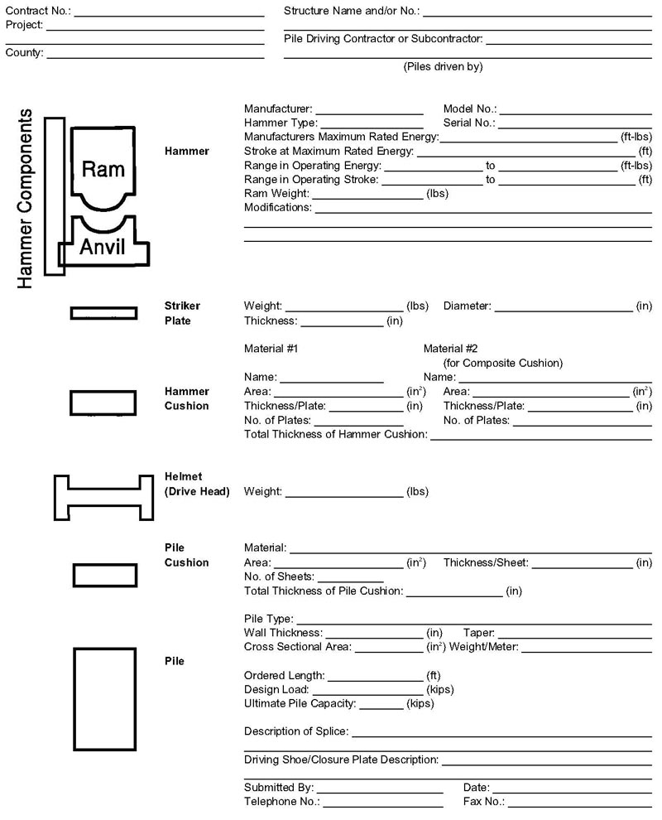

**Pile and Complete Driving Equipment Data Form (SI Units)**

